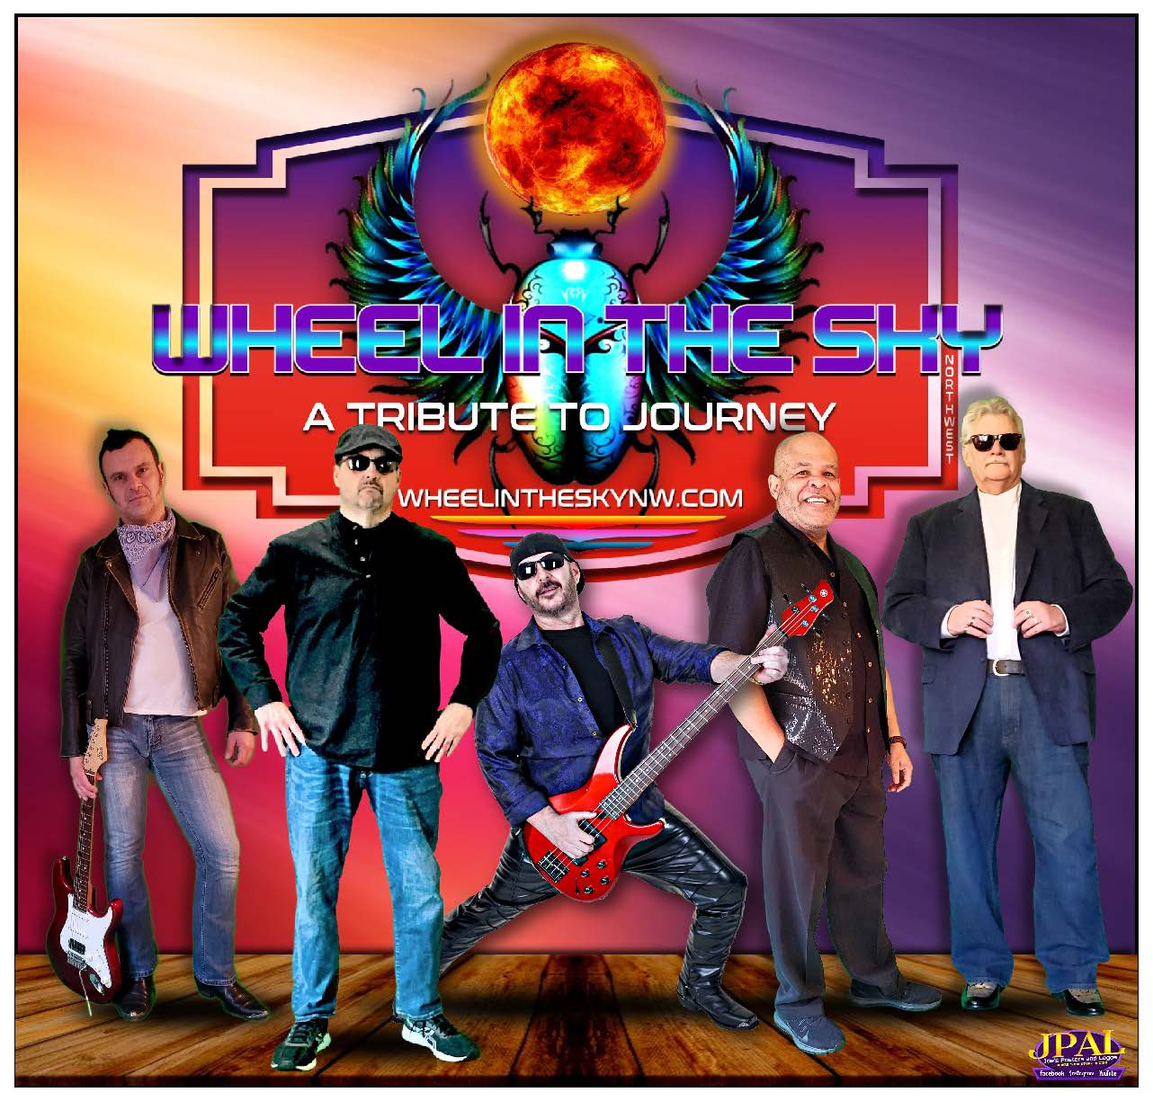

Wheel in the Sky NW is an All-Star group of Northwest Musicians, playing the music of Journey & Steve Perry.
Featuring the outstanding vocals of Ray Novelli and backed up by 4 of the Northwest's most experienced and talented musicians, Ron Fincher on drums, Billy D. on Bass, Jerry “The Doctor” Robertson on keyboards and the amazing Mario "Mars" Licciardi on Guitar, they bring to life the great melodies and outstanding harmonies we all love in the Music of Journey.
This band delivers a musically immersive Journey experience, focusing on the overall sound, solos, and most especially the soaring vocals that make Journey so iconic.
Wheel in the Sky NW takes you back to the '80's era when the timeless music of JOURNEY ruled the airwaves. The talent of these 5 musicians together has brought the meaning of TRIBUTE to a whole new level. See Wheel in the Sky NW to believe it!

